ECAN Depot Planner

Built using ArcGIS Web AppBuilder, for use with the ECAN Trip Splitter

# Configuration

Configuration is done through the WebApp Builder Interface

# Passing Parameters Through to the ECAN Depot Planner

The Trip Distance Calculator App can automatically add consents to map. These are passed through from the Trip Splitter in the URL. The format they follow is tripID then followed by no more than 20 consent numbers. It uses the HTTP GET method to pass the information. Below is an example of a URL:

**NOTE:** tripID MUST be before the CRC codes. Other variables can be passed through at any point in the URL provided that the CRC codes follow the tripID

Once the web page has loaded, you need to open the Trip Distance Calculator widget. Provided there is a tripID and consents in the URL, these consents will automatically be added to the map. The below image shows the added consents as green boxes.

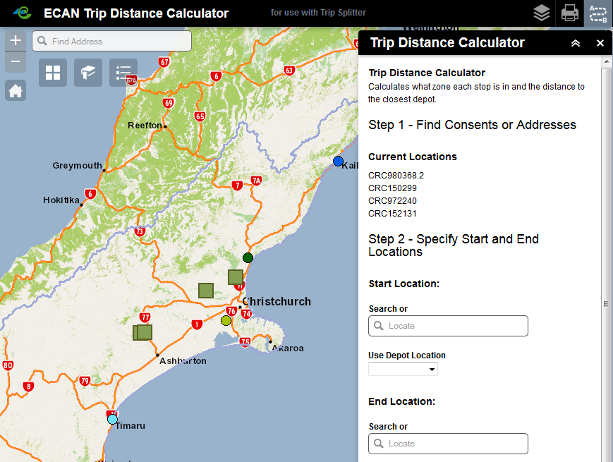

The user must enter or choose their start and end locations. They can either select one of the depots from the drop down list, or enter an address in the locator box. Only one of the options can be chosen for the start and end location. If the user has selected a Depot and entered an address, the widget will not run and will alert the user to the problem.

To solve this problem, users must either click the ‘x’ to the right of the address OR select the blank option from the drop down menu.

A user is able to start (or end) at an address and end (or start) at a depot, start and end at a depot and start and end at an address.

When entering an address, a dropdown will appear showing suggestions, the user can then click on this to select the location.

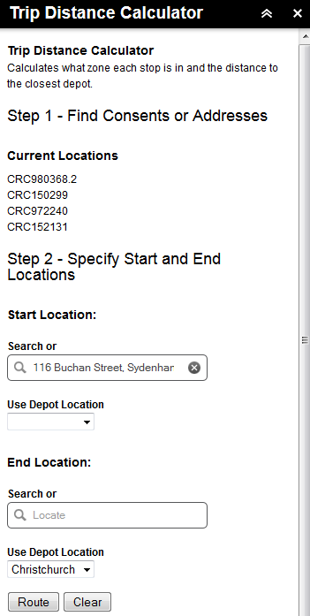

If you are happy with the Start and End locations you can click on ‘Route’. If not, click ‘Clear’ and this will clear the Start and End locations. Clicking ‘Route’ will do three things:

* Calculate the total length of the route. The route will always start and end on the Start/End locations and will find the optimal route between all the consents. The route is display on the map as a blue line. Below the ‘Route’ button, the total distance of the route will be displayed.
* Determine which depot zone each consent falls within and calculates the distance. For each consent location, the distance to the closest depot is calculate. This is displayed below the ‘Route’ button.
* Return the total chargeable distance. This is calculated by finding the shortest route between consents within the same zone and then summing all these values. The ‘written-off’ distance can then be calculated (subtract the chargeable distance from the total (travelled) distance).

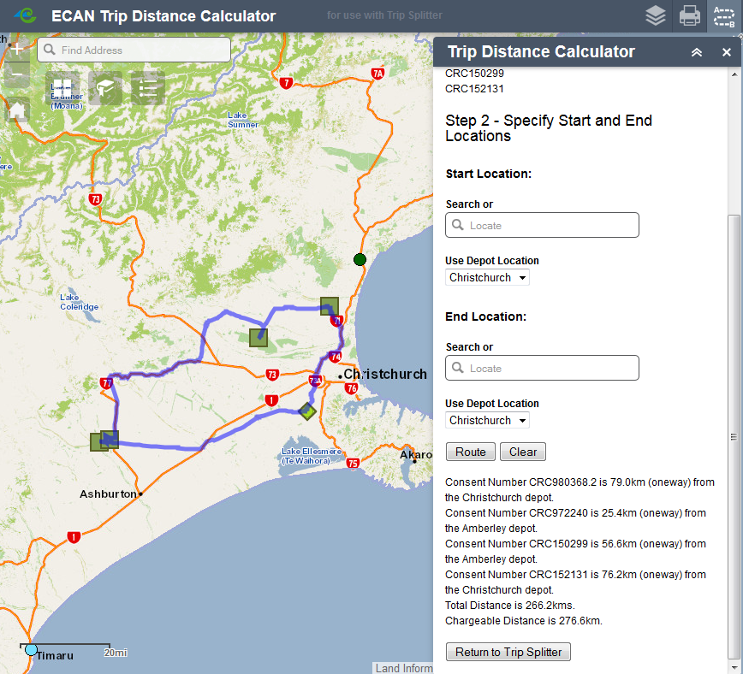

# Returning Results to the ECAN Trip Splitter

Once you have calculated your route, you are able return the result to the trip splitter. You can do this by clicking on the ‘Return to Trip Splitter’ button.

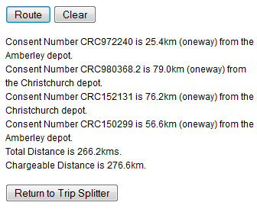

Within the Depot Planner, the results are stored in an object. The object contains the tripID, total trip length, consent numbers, closest depots, distance to closest depot and the chargeable distance (see below image).

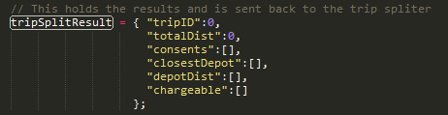

By clicking on the ‘Return to Trip Splitter’ button this object is converted to a GET method and appended to a url. The format of the GET method follows:

<url>/<webpage>.html?tripID=****&totalDist=****&crc0=CRC****&crcDepot0=***&crcDepotDist0=***&crc1…&crcDepot1…&crcDepotDist1…&chargeable=***

the

# Planning a Route without ECAN Trip Splitter

The Trip Distance Calculator widget can also be used without having passed a tripID or consents through. By navigating to the application (without any consents in the URL) you are able to open the Trip Distance Calculator widget. From there you can search for consents or addresses.

To search for a consent, enter the CRC code in the first box, click ‘Find’, and then ‘Add’. You will then see your consent added under ‘Current Locations’ and on the map. You may want to enable the consnets layer prior to this to see all the consents on the map.

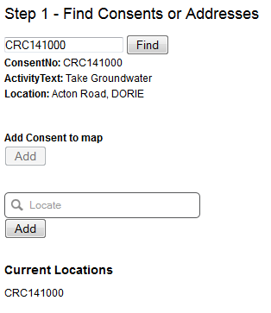

If there is no CRC code, the user can also enter a location. This is done in the second box. Once a user has found their location, they can click the ‘Add’ button below the box. This will add the location to the map and below ‘Current Locations’.

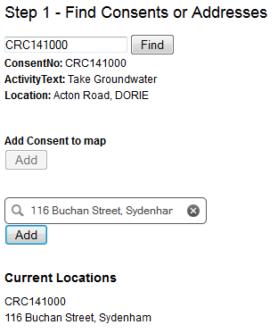

Once locations have been added to the map, you are able to remove them by clicking on ‘Clear’

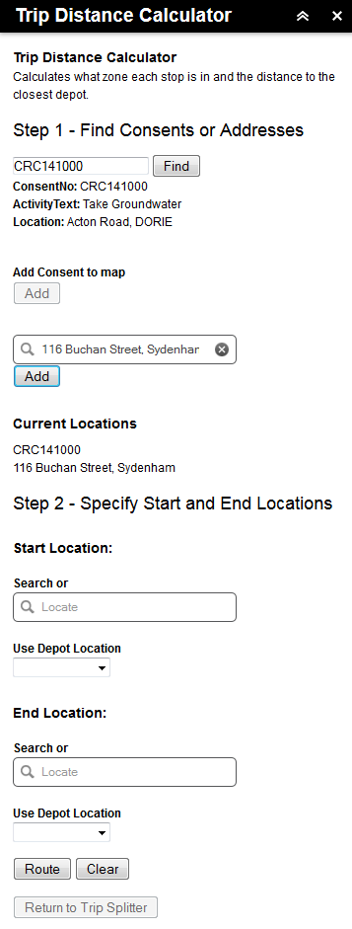

The user now needs to enter their start and end locations. This can either be a depot specified from the drop down list or and location from the search box. For more information, see Section 2.

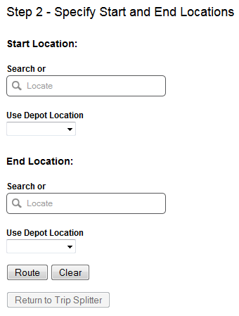

From here you can click on ‘Route’ and a route between the specified locations and the start/end locations will be calculated. The widget will also display which depot each consent is closest to and how far it is from each consent, the total distance of the calculated route and the chargeable distance. The chargeable distance is the distance of the route from the depot, to each (if any) of the consents in the zone and back to the depot.

# Issues

## Address locations

There is currently an issue with automatically geocoding the address of the depots. The x/y coordinates are specified in the config.json file. A problem arises with the geocoder when addresses are loaded into them. To ensure the depots are correct, the order in which the addresses are processed is important. Often, when the depot addresses were being geocoded one of the geocoders would finish before the one that started before it. This would result in the coordinates being out of order.

The image below shows the geocoding results in the console. The order they appear in (top to bottom) is the (correct) order in which they started to be solved. Notice the times to the right, the last geocoder was solved before the second and third result. This means that the variable holding the x/y coordinates is out of order.

